# About the Hands-on Labs

**Building Business Solutions with Power Apps and Flow (BBSPA)** includes a rich set of hands-on lab exercises designed to reinforce the key concepts and techniques that you learned in the lectures. The lab exercises for this training course were designed to run on a workstation or laptop running the Windows operating system. We recommend that you use Windows 10 but you can also Windows 8.1.

**DISCLAIMER**: While it is possible to complete many of the lab exercises for this course using a Mac instead of a Windows PC, the writeups for the lab exercises in this training course assume that you are using a Windows PC.

#### GitHub Repository for this course

Student files for this course are maintained in a GitHub fil repository at [**https://github.com/CriticalPathTraining/BBSPA**](https://github.com/CriticalPathTraining/BBSPA)**.**

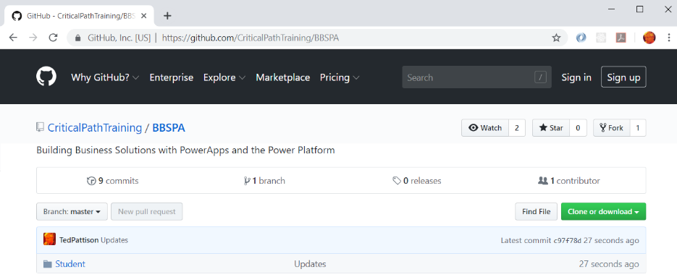

#### Student Workstation Prerequisites

All lab exercises should be completed on a student workstation that has the following software.

1. Windows 10 or Windows 8.1.
2. One or more Internet browsers (Chrome, Edge, IE, etc.)
3. Microsoft Excel 2016 or Microsoft Excel 2013 - *If you don't already have it, you can optionally install it during lab 1.*

#### Copying the Student Lab Files to Your Windows PC

The most recent version of the electronic student files for this course are kept in the **Student** folder of the GitHub repository for this course. You can download the zip archive for this repository from the following URL.

[**https://github.com/CriticalPathTraining/BBSPA/archive/master.zip**](https://github.com/CriticalPathTraining/BBSPA/archive/master.zip)

It is recommended that you that you download the master zip archive and make a local copy of the **Student** folder so that you have a local copy of the files you will need on your computer workstation when going through these labs exercise. Once you download the master zip archive, open it and copy the **Student** folder to a new local folder.

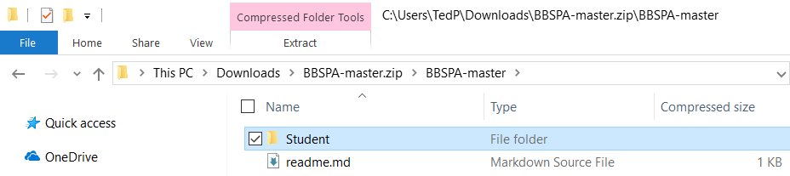

Copy the **Student** folder from the master zip archive to a new local folder at **C:\Student**.

